**COIMBATORE INSTITUTE OF TECHNOLOGY**

**(GOVERNMENT AIDED AUTONOMOUS INSTITUTION)**

**COIMBATORE , TAMILNADU**



**DEPARTMENT OF COMPUTING**

**(DECISION AND COMPUTING SCIENCES)**

**SUBJECT CODE: 22MDEL6**

**GOLANG LAB**

**REGISTER NUMBER: 71762233023**

**NAME: KEVIN JOSEPH T**

**REGISTER NUMBER: 71762233046**

**NAME: SHIVA PALAKSHA SG**

**Done by:  
Shiva Palaksha SG**

**Kevin Joseph T**

**GoImageFlow: Streaming Filters Pipeline via for microorganisms**

**GOLANG CAT-2 PROJECT REPORT**

**1. Introduction:**

The Micro Organism Analyzer is a Streamlit-based web application that leverages deep learning and image processing to classify microorganisms from uploaded images. The app integrates a pre-trained model with image transformation techniques and secure communication mechanisms via TCP and UDP protocols. It offers interactive visualizations, encrypted prediction transfer, and educational content, making it suitable for both research and learning environments.

**2. Objective:**

* Automatically identify and classify types of microorganisms from uploaded images using deep learning.
* Analyze the robustness of model predictions under various image transformations.
* Securely transmit prediction results using encrypted TCP and UDP communication.
* Facilitate prediction decryption, comparison, and reporting within a user-friendly interface.
* Educate users about microorganisms and receive feedback to enhance the application.

**3. Dataset Overview:**

The model was trained using a labeled dataset of microorganism images sourced from microscopy archives. The dataset includes:

* Classes: Bacteria, Viruses, Fungi, Protozoa, Algae.
* Image Format: RGB images in .jpg or .png.
* Training Pipeline:
* Images were preprocessed to a uniform size (299x299).
* Data augmentation techniques like rotation, zoom, and flipping were applied.
* The dataset was split into training (80%) and validation (20%).

This dataset allowed the InceptionV3 model to learn distinguishable features between different microorganisms, achieving high accuracy on unseen data.

**4. Methodology:**

**Workflow:**

**1. Upload Image:** User uploads an image through the app.

**2. Initial Prediction:** Image is preprocessed and passed to a pre-trained InceptionV3 model.

**3. Transformations:** Multiple image transformations can be applied:

* Flip, Rotate, Grayscale, Blur, Edge Detection, etc.

**4. Comparison:** Predictions from the original and transformed image are compared.

**5. Prediction Transfer:**

TCP Client: Encrypts and sends prediction with image in base64 to a TCP server.

UDP Client: Optionally sends predictions as plain JSON via UDP.

**6. Decryption Page:** XOR cipher decryption of prediction using 8-digit key.

**7. Report Generation:** Generate PDF with prediction and transformation results.

**5. Technologies Used:**

|  |  |
| --- | --- |
| **Category** | **Tools/Frameworks Used** |
| **Frontend** | Streamlit, Streamlit Image Upload, st.video |
| **ML Model** | TensorFlow, Keras (InceptionV3) |
| **Image Processing** | OpenCV (cv2), PIL (Pillow) |
| **Encryption** | XOR-based encryption for TCP prediction messages |
| **Data Transfer** | socket (TCP & UDP client) |
| **Utilities** | base64, json, reportlab (for PDF), os, io |

## ****6. Key Features:****

### a. **Home Page:**

* Introduction to microorganisms and their types.
* Embedded educational video.

### b. **Image Classifier:**

* Upload, preview, and apply transformations to microorganism images.
* Predict class using ML model.
* Display confidence score.
* Encrypt and send prediction to TCP or UDP server.

### c. **Decryption Page**

* Input 8-digit key and encrypted message to decrypt prediction.

### d. **Comparison Page**

* Display predictions before and after transformation.
* Generate a downloadable PDF report summarizing the result.

### e. **UDP Support**

* In addition to TCP, the app includes a **UDP client**.
* Predictions are serialized as JSON and sent over UDP to 127.0.0.1:54321.
* Lightweight and faster communication with lower overhead.

**RESULTS (OUTPUT):**

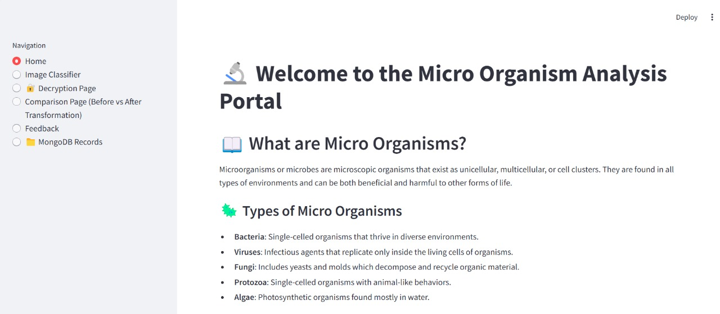

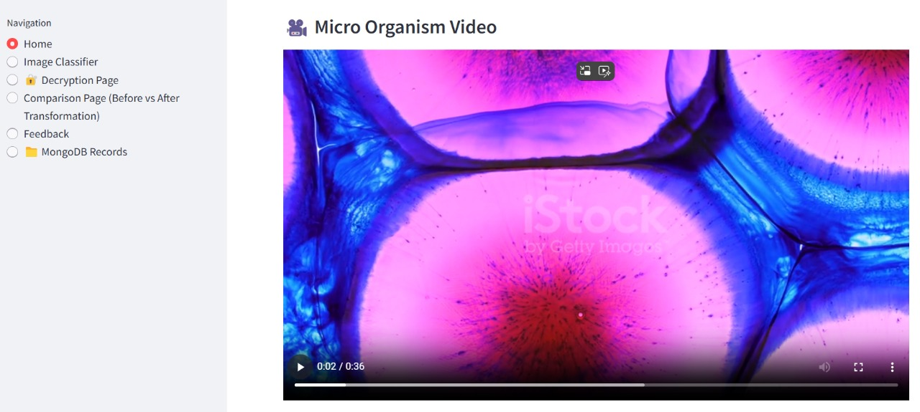

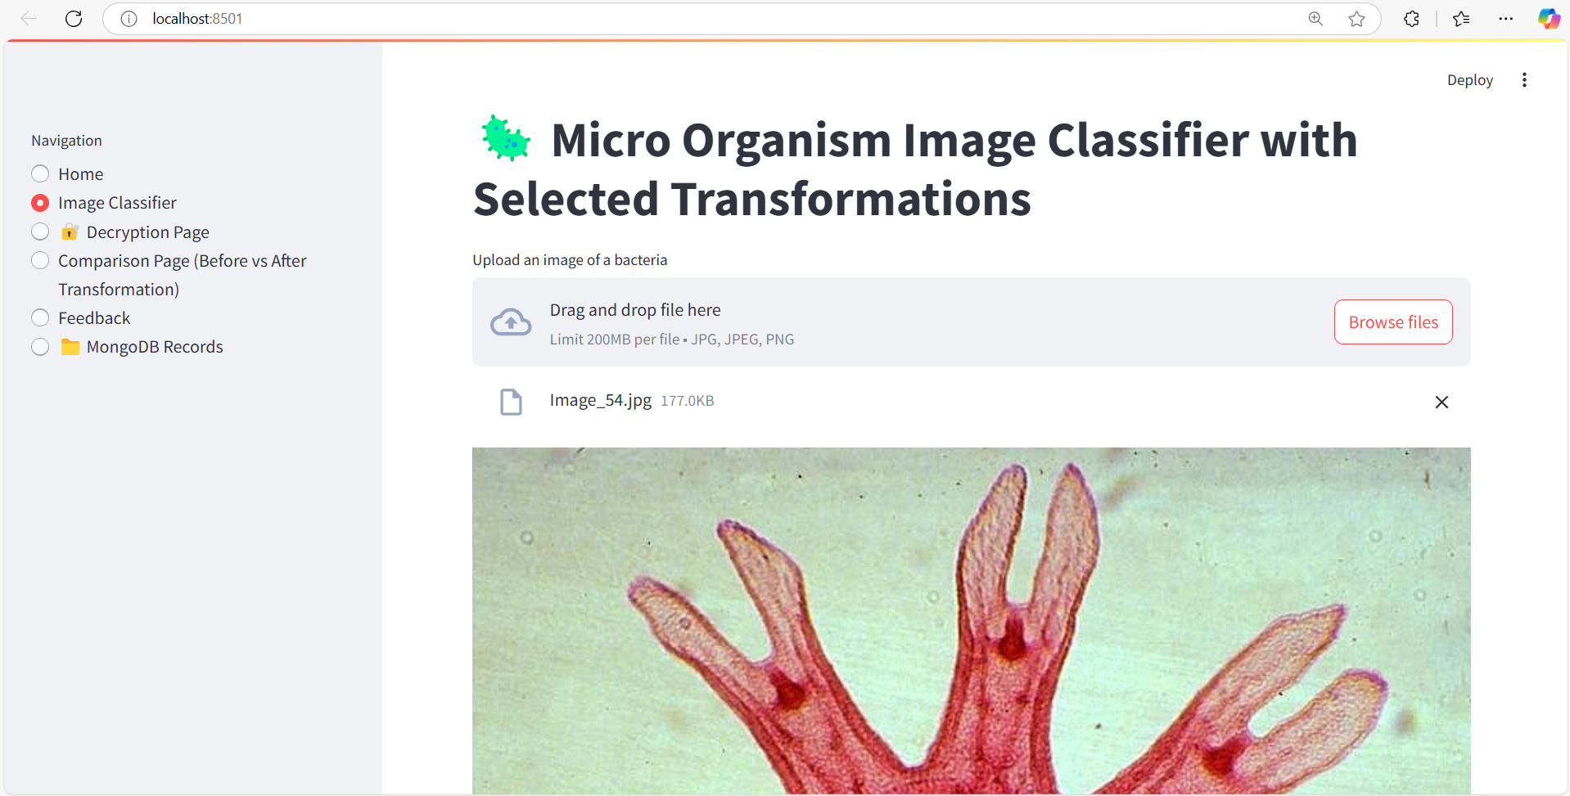

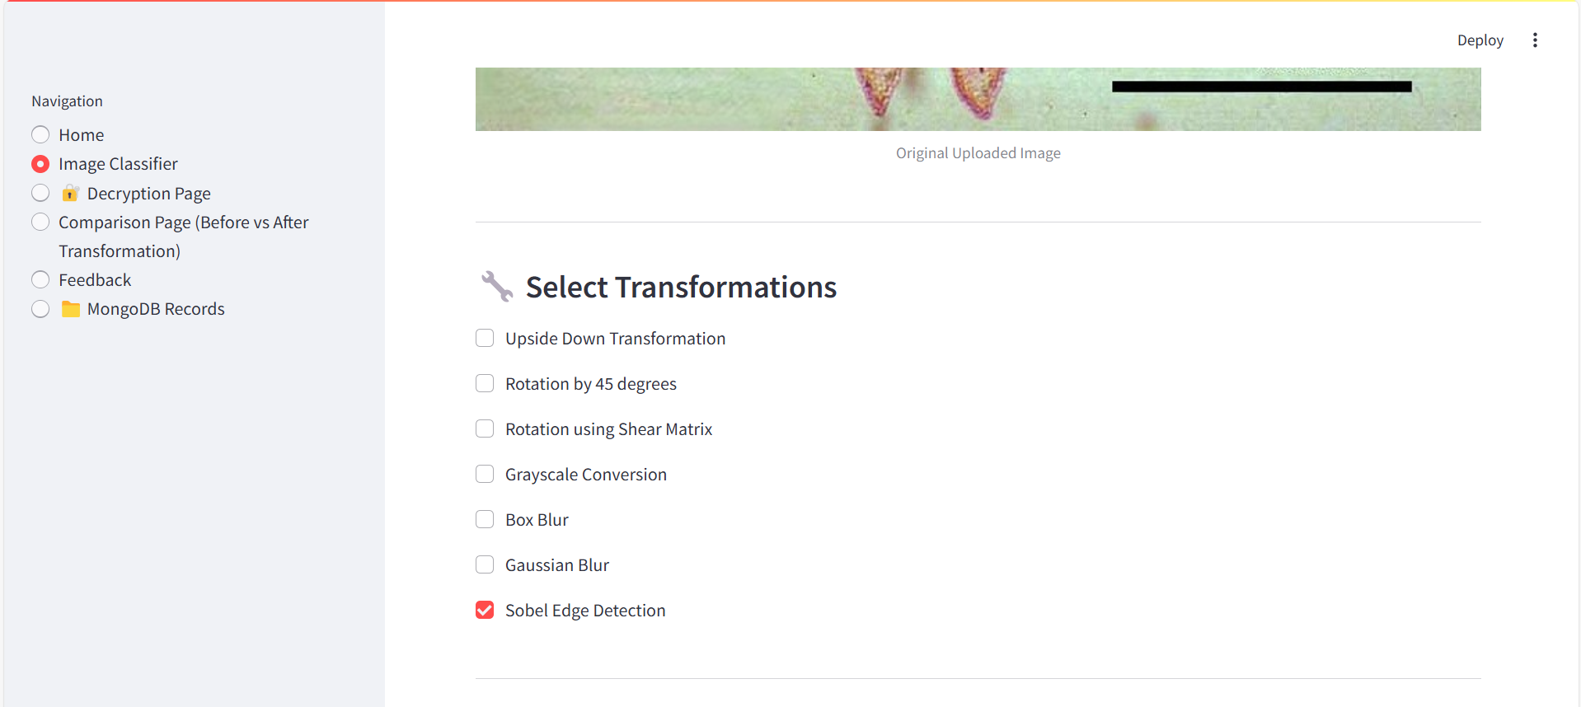

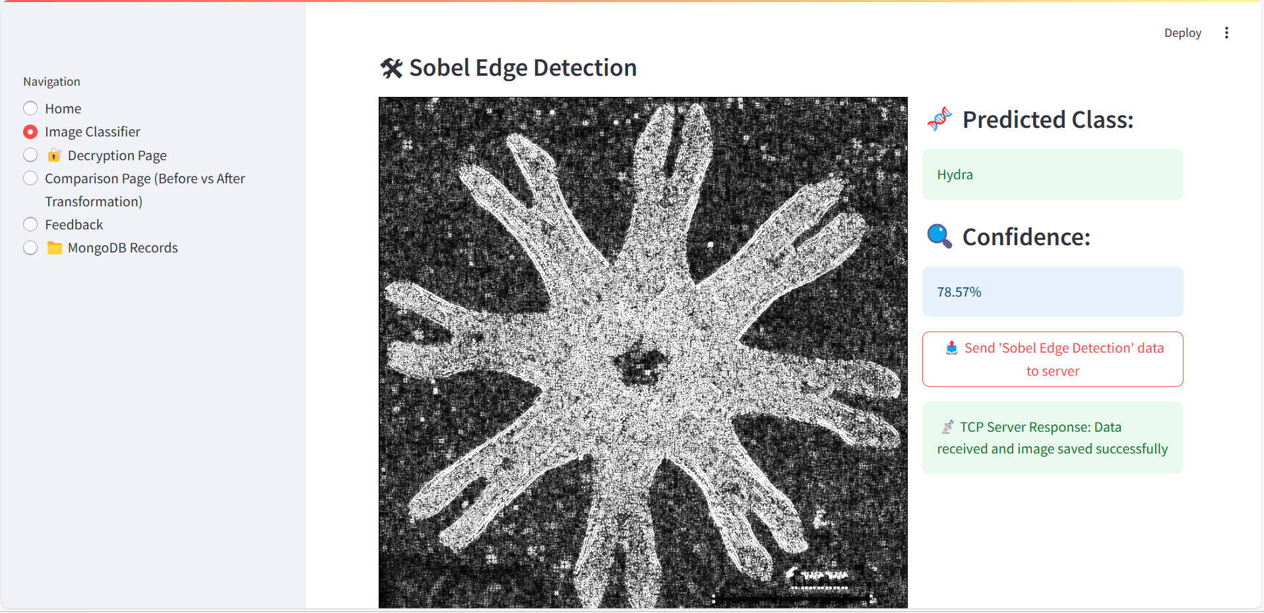

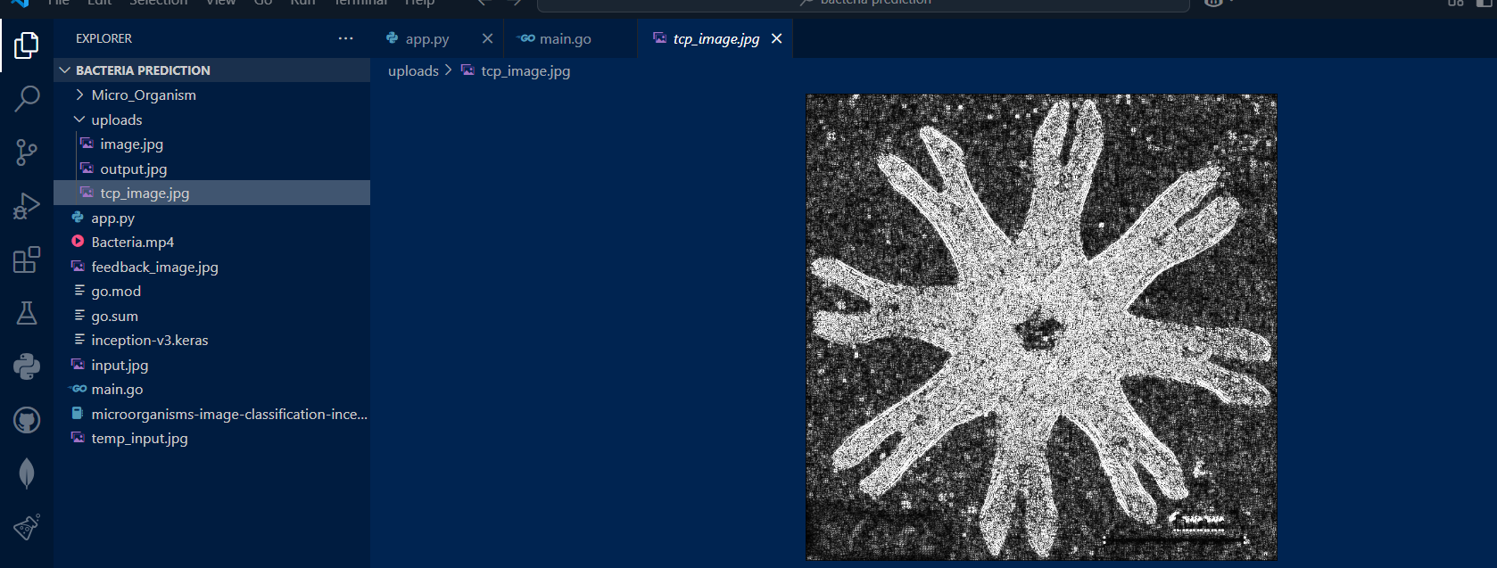

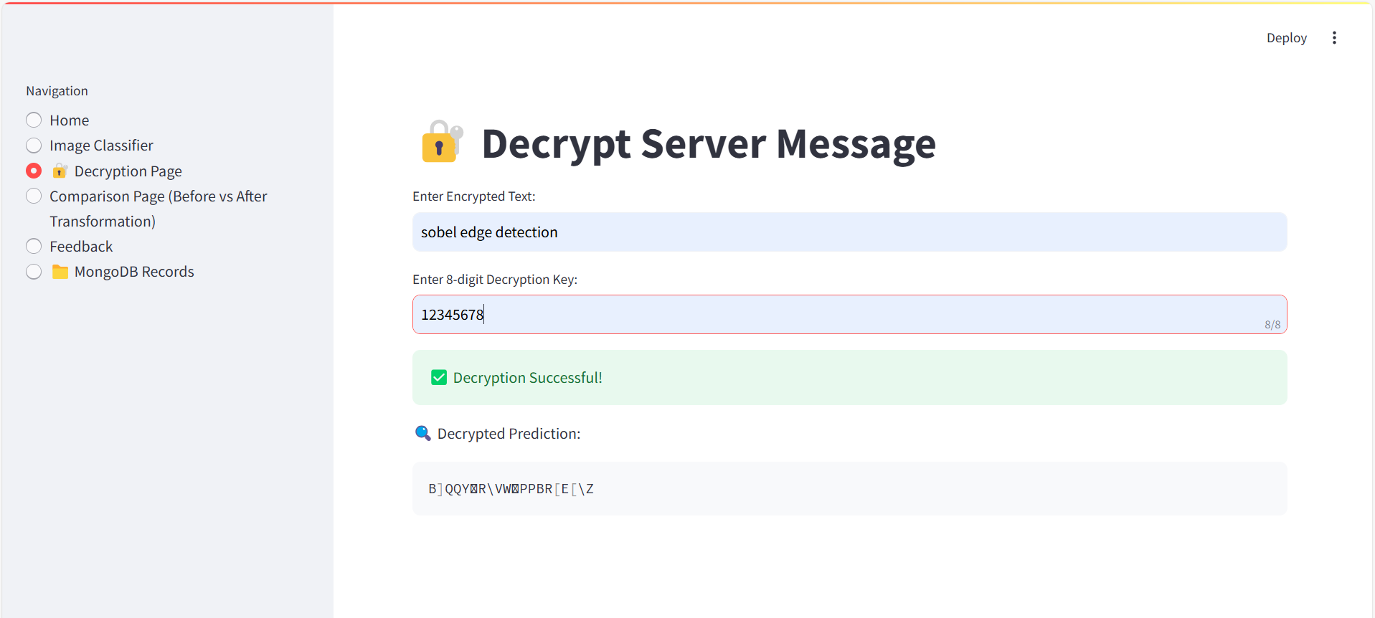

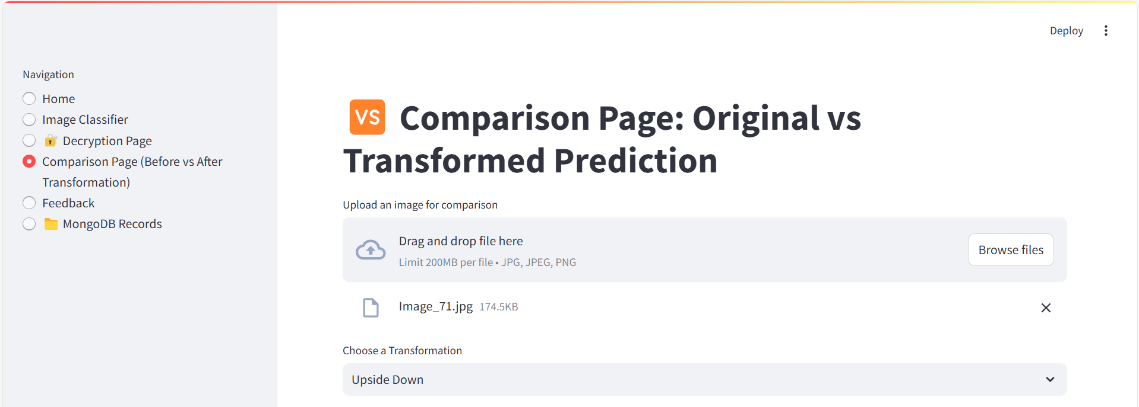

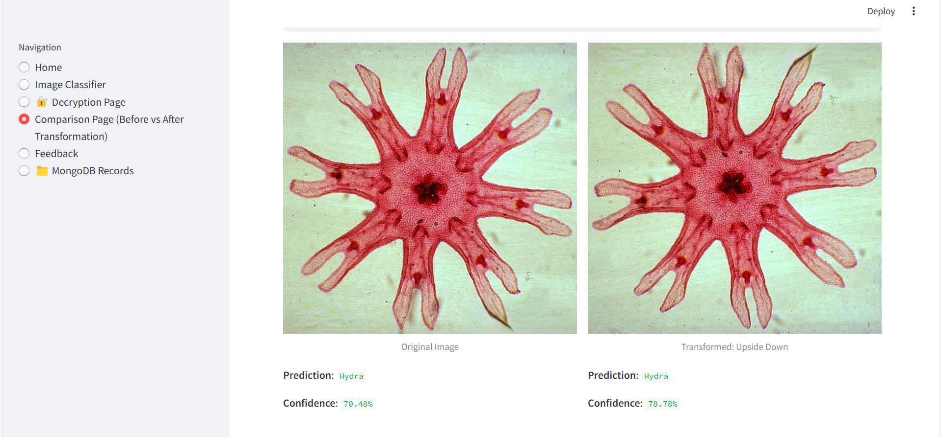

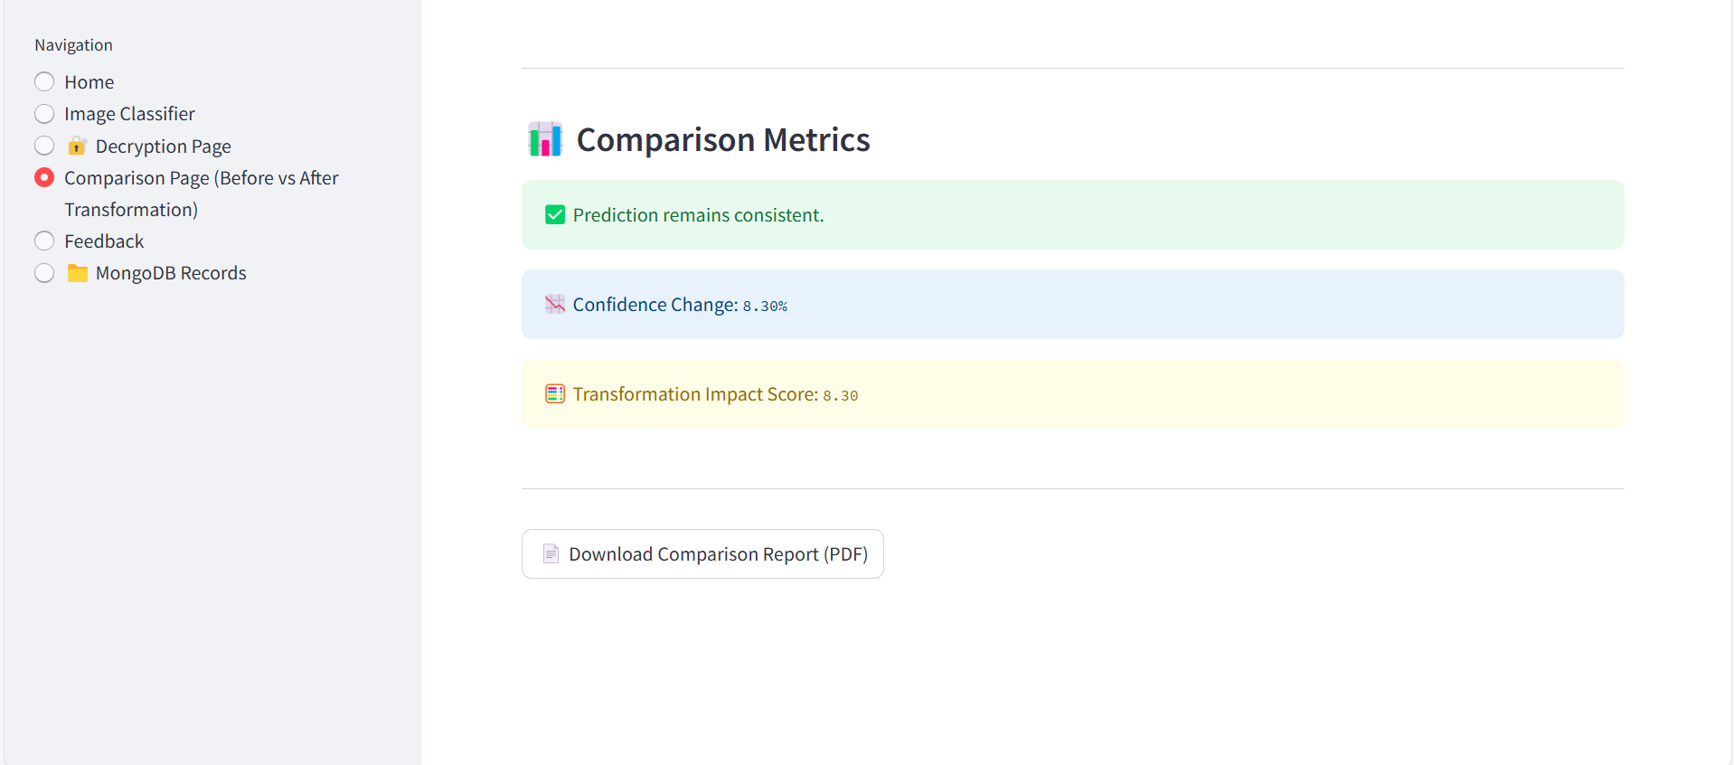

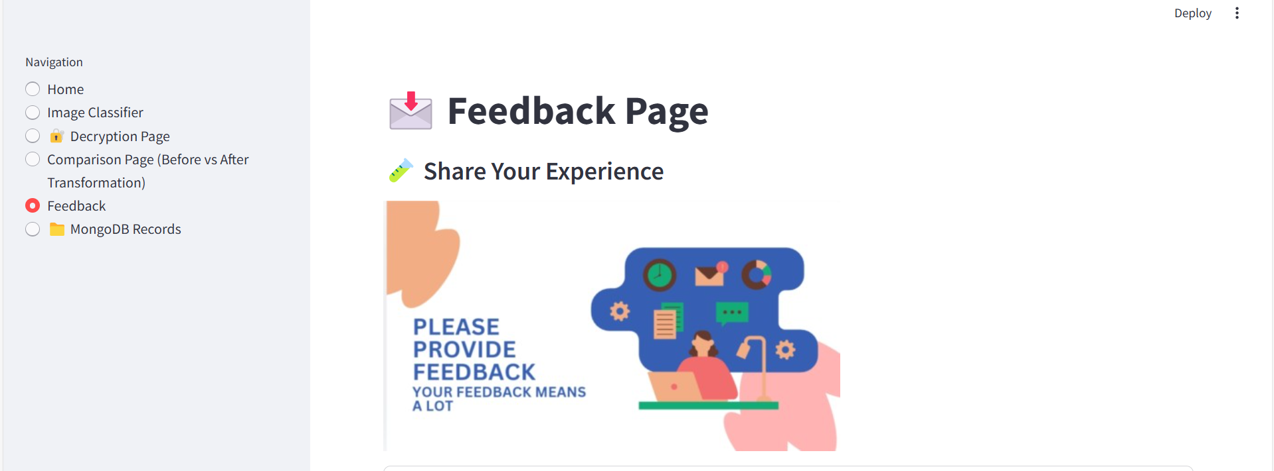

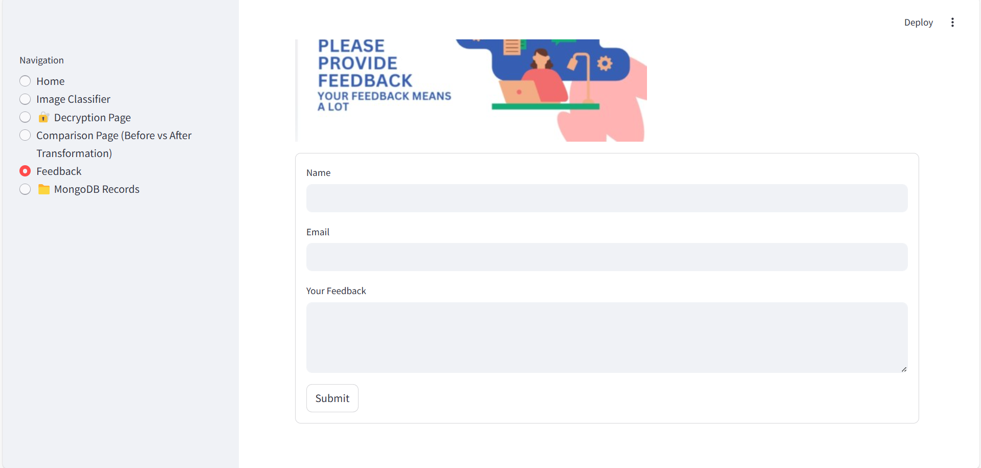

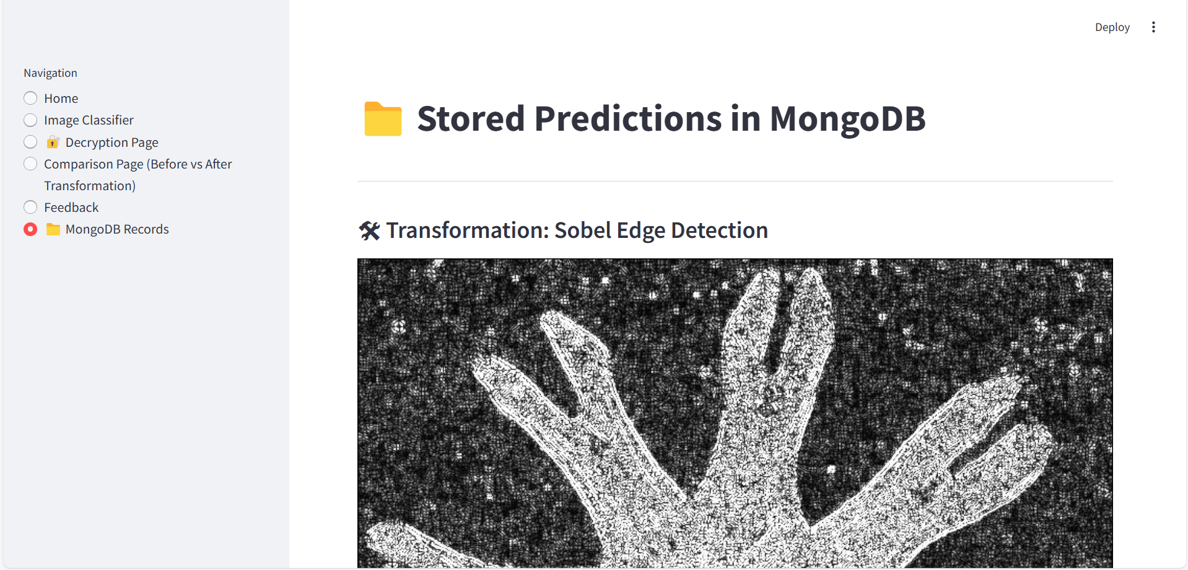

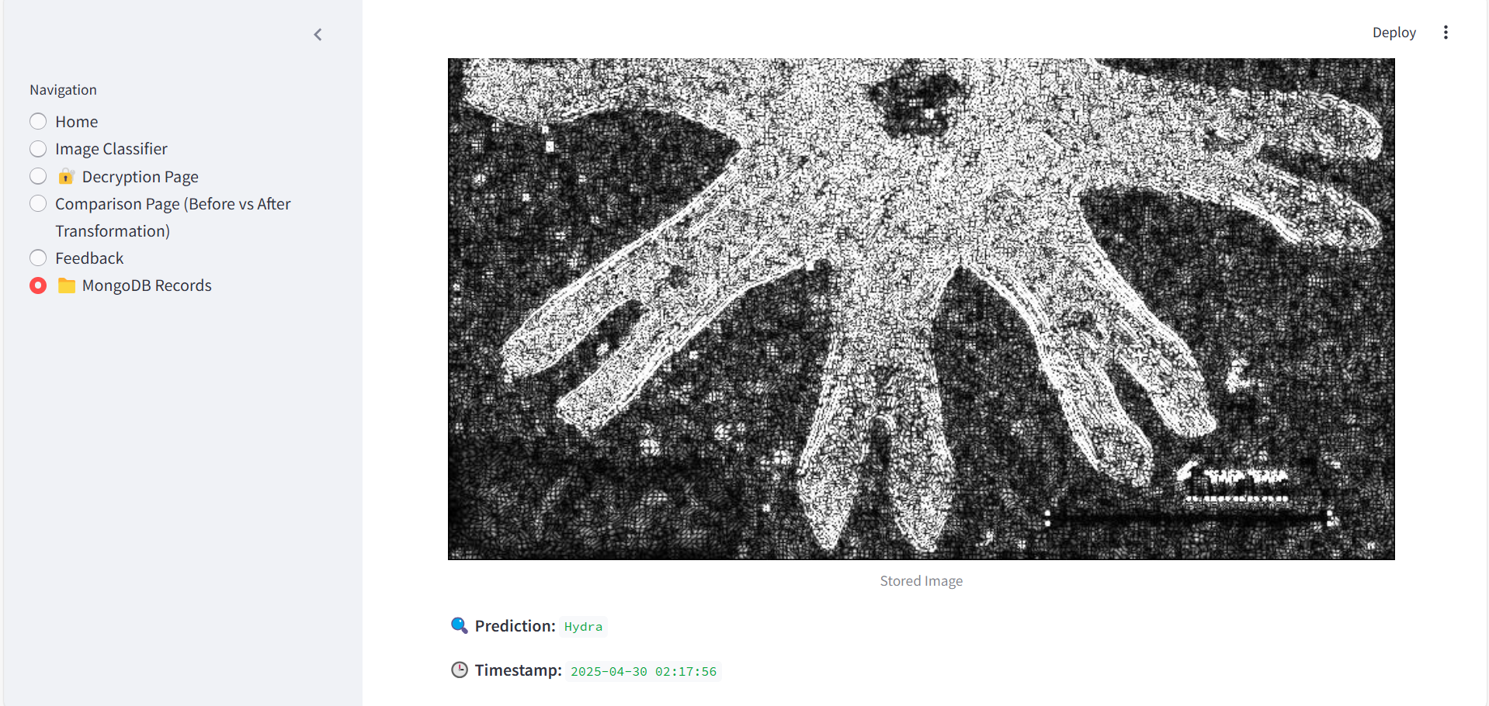

**8. Future Insights:**

To expand and improve the *Micro Organism Analyzer*, future enhancements include:

* **Live Microscopy Integration**: Connect the app to live microscope feed for real-time predictions.
* **Dataset Expansion**: Include more diverse microorganism types and real-world noisy samples.
* **Transfer Learning with Custom Models**: Fine-tune advanced architectures (e.g., EfficientNet).
* **Feedback-Based Model Improvement**: Use user feedback to retrain the model (active learning).
* **Server-Side Logging**: Add centralized server to log predictions, errors, and user actions.
* **Multi-language Support**: Translate the interface for global reach.
* **Mobile App Version**: Create a lightweight mobile version using Flutter or React Native.
* **API Integration**: Expose prediction engine via REST API or gRPC for external access.

## 9. Database Connectivity (MongoDB)

To persist user interactions, predictions, and system responses, the Micro Organism Analyzer integrates MongoDB for document-based storage. This allows historical prediction tracking, transformation data archiving, and user activity logging.

🔗 MongoDB Integration Details:

* Database: microorganism_analyzer
* Collections:
  + predictions: Stores image prediction records.
  + decryptions: Stores decrypted prediction messages with user key input.
  + logs: Records app usage (e.g., transformation actions, errors).
* Format: Each document is stored as a JSON-like BSON object.

Sample prediction document:

{ "timestamp": "2025-04-30T12:35:20Z", "filename": "fungi_sample.jpg", "original_prediction": { "class": "Fungus", "confidence": 0.91 }, "transformation_applied": "Grayscale", "transformed_prediction": { "class": "Fungus", "confidence": 0.88 }, "user_feedback": "Correct", "key_used": "12345678" }

🔌 Code Snippet (Python + PyMongo):

from pymongo import MongoClient from datetime import datetime

client = MongoClient("mongodb://localhost:27017") db = client["microorganism_analyzer"] collection = db["predictions"]

record = { "timestamp": datetime.utcnow(), "filename": filename, "original_prediction": original_pred, "transformed_prediction": transformed_pred, "transformation_applied": transform_name, "user_feedback": feedback, "key_used": user_key }

collection.insert_one(record)

This approach ensures that predictions and interactions can be analyzed, audited, and improved in the future.